Sussex Safeguarding Adults Boards
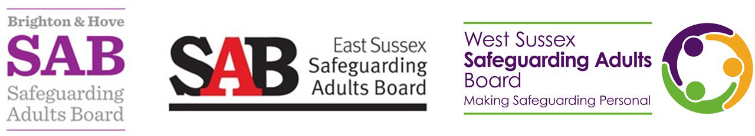

Adult death protocol Follow-up meeting agenda

Item | Subject
1. | Welcome, introductions and apologies
2. | Purpose of meeting
3. | Review of actions from each agency
4. | Next steps including:  - Case recommendations  - Strategic actions  - Governance
5. | AOB
Statement of confidentiality/equal opportunities and professional differences
All information discussed in this meeting is confidential. Organisations and individuals will aim to maintain the balance between the need for confidentiality and the sharing of information on a ‘need to know’ basis in the interests of safeguarding adults. In certain circumstances it may also be necessary to make information from the meeting available to third parties such as other professionals involved in the care and support of adults, and this will be recorded.
It is expected that all participants in the meeting will treat each other with respect, and that sensitivity to aspects of difference such as gender, disability, ethnicity, cultural and religious background is observed.
Any comments that contribute to discrimination are not acceptable and will be challenged by the Chair and other members of the meeting.
‘It is acknowledged that when working in the arena of safeguarding, it is inevitable that from time to time there will be professional differences. This is a positive activity and a sign of good professional practice and effective multi-agency working. During this meeting practitioners, irrespective of their seniority are encouraged to say if they feel that decisions, practice or actions do not effectively promote safeguarding or address objectives of this Adult Death Protocol.

